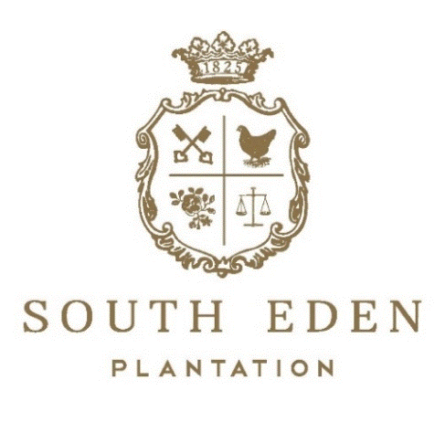

We want to get to know you & your wedding a little bit more to give you a tentative estimate for the cost of your beautiful day! Below are a few questions to help us understand your dream wedding. Please fill out this questionnaire as best you can & email to: gabrielle@southedenplantation.com

- First & Last Name:

- Budget Range you would ideally need stay within for our services of catering, venue spaces, facility rentals, etc.:

- What is your estimated headcount of guests?
  - (Please note: This includes the wedding party & yourself.)

- Would you be booking the Bridal Preparation Suite, a groomsmen suite, Bride/Groom Wedding Night Suite, OR any other overnight guest suites?
  - (Please note: We have 24 overnight guest suites on property)

- Do you want any catering additions to the Bridal Suite OR Groomsmen Suite such as mimosa bar, beer buckets, cheeseboards, fruit platter, and/or paninis?

- Which venue(s) on property did you want to rent? (Please refer to our Venue Locations Sheet)
  - (Please note: Cocktail Hour & Reception Venue are commonly hosted in the same venue space.)

  - Ceremony Venue:

  - Cocktail Hour Venue:

  - Reception Venue:

- Would you like farm tables, round tables, OR a mixture of both for the reception?

- Would you like a sweetheart table & couch OR will the bride/groom sit with family?

- Would you like any ceremonial decorative additions such as a gazebo, arbor, wood-crafted cross, OR pergola?

- Would you like a reception table centerpiece package? (This is tabletop décor for each reception table styled & themed based on your wedding colors, floristry, & vision.)
  - (Please note: This is only décor/ NOT floral arrangements.)

- Would you like any a la carte furniture OR a furniture lounge area package? (This is styled & themed based on your wedding colors, desires, & vision.)

- Do you desire a dance floor?
  - (Please note: Showboat Theatre cannot have a dance floor; Must be rented for any outdoor venue location.)

- If doing a cocktail hour, which appetizers would you select? (Please refer to our Appetizer Menu)

  - Would you like them stationed, butler passed, OR both?
    - (Please note: The standard service style is stationed appetizers. Butler Passed is more expensive. Also, some appetizers cannot be butler passed due to hot dishes being needed.)

- Do you want an open bar (Host pays entire bar tab) OR Cash/Credit Bar (Wedding guests pay for their own bar tab)?

- Would you like a champagne toast at each place setting?

- Which dinner menu tier would you select? (Please refer to our wedding dinner menu tiers)

  - Would there be any menu additions OR customizations at this time?
    - (Please note: The standard service style is buffet. Please contact your South Eden representative if this is not suitable.)

- Do you want any specialty food stations such as: Candy Bar, Chocolate Bar, Smores Bar, Hot Cocoa Bar, Coffee Bar, Mimosa Bar, Donut Bar, etc.?

- Will there be a need for any after party taking place on property?
  - (Venue lease ends at 12AM)

  - If yes, then will you need any food additions such as a late night pizza bar ($25 per person)?

- Would you like a post-wedding day breakfast?
  - (Please note: This only applies to 30+ group sizes.)

