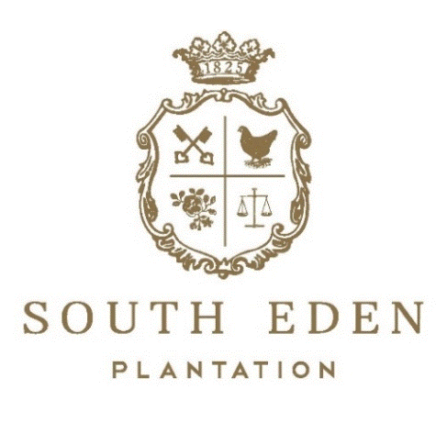

We want to get to know you & your wedding a little bit more to give you a tentative estimate for the cost of your beautiful day! Below are a few questions to help us understand your dream wedding. These details can change later but, are used to create your custom wedding package. Please fill out this questionnaire as best you can & email to: gabrielle@southedenplantation.com

- First & Last Name:

- Preferred Wedding Date(s) if any:

- Budget Range you would ideally need stay within for our services of catering, venue spaces, facility rentals, floristry, etc.:

- What is your estimated headcount of guests?
  - (Please note: This includes the wedding party & yourself.)

- Would you be booking the Bridal Preparation Suite OR groomsmen suite?
  - Please Note: Honeymoon Suites & Other overnight suites available at our Hotel.

- Would you like any catering additions to the Bridal Suite OR Groomsmen Suite such as mimosa bar, beer buckets, cheeseboards, fruit platter, and/or paninis?

- Which venue(s) on property did you want to rent? (Please refer to our Venue Locations Sheet) - (Please note: Cocktail Hour & Reception Venue are commonly hosted in the same venue space.)

  - Ceremony Venue:

  - Cocktail Hour Venue:

  - Reception Venue:

- Would you like any ceremonial decorative additions such as a gazebo, arbor, wood-crafted cross, OR pergola?

- Would you like a reception table centerpiece package? (This is tabletop décor for each reception table styled & themed based on your wedding colors, floristry, & vision.) - (Please note: This is only décor/ NOT floral arrangements.)

- Would you like any a la carte furniture OR a furniture lounge area package?

- Do you desire a dance floor? - (Please note: Showboat Theatre cannot have a dance floor; Must be rented for any outdoor venue location.)

- If doing a cocktail hour, which appetizers would you select? (Please refer to our Appetizer Menu) - (Please note: The standard service style is stationed appetizers.)

- Which dinner menu tier would you select? (Please refer to our wedding dinner menu tiers) - (Please note: The standard service style is buffet.)

  - Would there be any menu customizations at this time?

- Do you want a wine/beer open bar package (Host pays entire bar tab) OR Cash/Credit Bar (Guests pay for their own bar tab)?

- Would you like a champagne toast at each place setting?

- Do you want any specialty food stations such as: Candy Bar, Cookie Bar, Smores Bar, Hot Cocoa Bar, Donut Wall, etc.?

- Will there be a need for any after party taking place on property? (Venue lease ends at 12AM) –

  - If yes, then will you need any food additions such as a late night pizza bar ($25 per person)?

- Would you like a post-wedding day breakfast? (Please note: This only applies to 30+ group sizes.) -

- Will you be desiring a Rehearsal Dinner Quote as well?

  - If so, how many guests are you looking at for this?

